NOTE: The end of the line that you work with in tying knots is called the "Tag End" or "Bitter End." The main length of line is the "Standing Part." On average, any knot will reduce the breaking strength of any line or rope by about 15%. Along with the boating knots I have listed the typical percentage of line breaking strength remaining after tying the given knot.

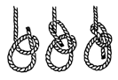The Bowline (BOH'-LIN) is considered the boaters' prime knot. It is used to make a fixed-size loop in a line. The bowline is used to tie sheets and halyards (control lines) to sails, to temporarily tie a rode (anchor line) to an anchor, tie a fender to a cleat/rail or, using one knot on each line, tie together 2 lines of different diameters. Two bowlines tied close together can be used to make an emergency bowswain's chair to go up the mast or bring an injured person aboard.
The benefits of the bowline are in its loop that will not slip, and in its ability to be untied after being exposed to a strain.
To tie a bowline:
- Begin with a small overhand loop (the loop goes over the standing part - attached or long end of the line.) Be sure to leave enough in the bitter end (free end) to form the loop.
- Form the loop of desired size.
- Pass the bitter end up through the small loop, around the standing part, and back through the small loop, this time going down.
- Tighten it up.
- 67% - 75% line breaking strength remaining.
You know you have it correct when the bitter end is in the inside of the loop.
Follow the boating and fishing knot links to the right for more clear pictures, directions and some animations on how to tie several popular boating and fishing knots.

A commonly used knot to tie a loop in the end of a rope. It has the advantage of not jamming, compared to some other loop forming knots (for example when using an overhand knot on a large bight to form a loop).

Form a small loop (the direction is important), and pass the free end of the knot up through the loop, around behind the standing part of the rope, and back down through the loop.

A chant used by many to remember this knot is "The rabbit comes out of the hole, round the tree, and back down the hole again", where the hole is the small loop, and the rabbit is the running end of the rope.

In the same way that a Left Handed Sheet bend is a Sheet bend that has the running end of the rope coming out of the wrong side of the knot, a cowboy bowline is a bowline that also has the running end of the rope coming out of the wrong side of the knot. It suffers the same problems as the left handed sheet bend.

Tip. Don't be afraid to use this knot to form a loop of any size in rope.

Tip. To quickly identify if you have tied the Bowline normal or left handed, check to see that the running end exits the knot on the inside of the loop.

Tip. For added security, finish the knot with a stop knot such as a Figure of Eight knot to remove any possibility of the Bowline slipping.

Tip. If you use this knot in a man carrying situation - perhaps a rescue where a harness is unavailable - then you MUST use a stop knot as mentioned above.

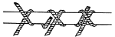
The Clove Hitch is used to tie a line to a piling or bollard. This knot can be used to tie fenders to a railing. Although this knot is handy because of its simplicity, it should only be used to temporarily tie a boat to a piling, and only if the boat is being watched. The clove hitch can jam under heavy tension, making it difficult to untie. Worse, is its tendency to untie itself when subjected to repeated strain and release such as a boat rocking in waves. Despite these weaknesses the clove hitch is still ideal when temporarily tieing up at a fuel dock or for fenders.
To tie a clove hitch:
- Begin with a loop around the piling.
- Start a second loop around the piling, making sure you cross up, over the first loop.
- Come around the piling and tuck the bitter end (free end) under the SECOND loop.
- Tighten it up.
- 60% line breaking strength remaining.

Use to attach a rope to a pole, this knot provide a quick and secure result. It rarely jams, and can in fact suffer from the hitch unrolling under tension if the pole can turn. Often used to start and finish lashings.
Tip. If you are in a situation where the clove hitch may unroll, add a couple of half hitches with the running end to the standing end of the knot, turning it into a "Clove Hitch and Two Half Hitches"!
Tip. When pioneering, use the Round turn and two half hitches to start and finish your lashings instead of the Clove Hitch. It won't unroll, and is easier to finish tying off. It just does not look so neat!

- 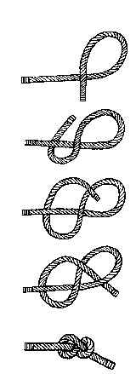
This Figure Eight Knot (Flemish Knot, Savoy Knot) is larger, stronger and more easy to untie than the overhand knot. It does not harm your rope as much as the overhand knot does. Sailors use this knot in most cases, not for bend support, where the smaller overhand is used, or in rope, but for a permanent small stopper.
To tie a Figure Eight Knot:
- Interlock the overhand loops.
- The running part then goes through the eye of one loop and the standing part goes through the eye of the other loop.
- Pull the running part and standing part tight.

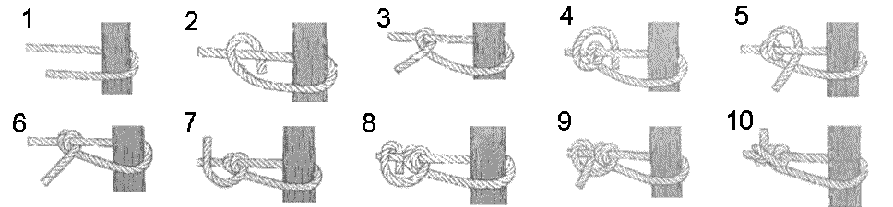

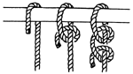
The double half hitch is commonly used to tie a line to a post or dock eye. This knot will slide, resulting in a tight grip on the post. The knot can slip apart under high stress loads so it should NOT be used for "mission-critical" things like tieing a rode to an anchor.
The benefits of the bowline are in its loop that will not slip, and in its ability to be untied after being exposed to a strain.
To tie a double half hitch:
- After coming around the post, make an underhand loop (the loop goes under the standing part - attached or long end of the line.)
- Bring the bitter end (free end) up over the standing part and through the eye which you created.
- Next make a second underhand loop around the standing part, and run the bitter end through this eye.
- Tighten it up.
- 65% - 75% line breaking strength remaining.
Used to secure a rope to a pole, or to start or finish a lashing. Pass the running end of the rope over the pole twice. Then pass the running end over the standing part of rope, and tuck it back up and under itself, forming a half hitch. Repeat this for a second half hitch.
This knot has a redeeming feature - it rarely jams!
Tip. Superior to a Clove Hitch for starting and finishing a lashing as the half hitches prevent this knot from unrolling, as they have the effect of locking the knot. The Clove Hitch looks neater (!) but it has a tendency to unroll, and can be difficult to tie tightly when tying off.

The Taught Line Hitch.
This knot is easy to tie and makes adjusting the sling line length very easy, without having to re-tie the knot each time. All one has to do is release the line from any tension and then slide the knot to the desired position. It will require you to keep an eye on it, since the action of hurling can cause the knot to start loosening up a little bit, which can eventually lead to it coming apart, but I've never had any trouble with it.

Rolling Hitch
One of the most underated knots in Scouting and Guiding, the Rolling hitch is used to attach one rope to a second, in such a manner that the first rope can be easily slid along the second.
The knot can be considered a Clove hitch with an additional turn.
When tension is applied and the ropes form a straight line, the rolling hitch will lock onto the first rope. When the tension is released, the hitch can be loosened and slid along the first rope to a new location.
The tension must be applied on the side of the knot with the extra turn.
Tip. Use this knot if you have a guy rope with no adjuster. Create a loop on the end of a second rope which is slipped over the peg. Use a rolling hitch to attach the second rope to the guyline. Alternatively, take the guyline around the peg and tie the Rolling hitch back onto the standing part of the guyline, above the peg, thus forming an adjustable loop. This is known as the Tautline Hitch in America.
Tip. Use this knot when constructing camp gadgets such as a suspended table. A Rolling hitch in each suspension rope will allow easy adjustment and a level table!
Tip. When adjustments are complete, lock the rolling hitch into place by using a stop knot such as a Figure of Eight in the first rope, below the Rolling hitch, to stop it slipping.

The Fisherman's knot is used to tie two ropes of equal thickness together. It is used by fishermen to join fishing line, and is very effective with small diameter strings and twines.
Tie a Thumb knot, in the running end of the first rope around the second rope. Then tie a thumb knot in the second rope, around the first rope. Note the Thumb knots are tied such they lie snugly against each other when the standing ends are pulled.

