Tip of the Week

November 22, 2004

Hoisting Equipment
One thing we have to do on almost every job is to hoist equipment to the test location. There are as many ways of doing this as Jim Burton has spent hours on a stack. Every piece of equipment has a good way, and a not-so-good way to be lifted off the ground. Rather than analyze each and every one of these, the following basic guidelines should be considered:

- Always be safe.
- Avoid trusting handles by themselves as hoisting points. Whenever possible, first wrap the rope around the object (cooler, toolbox, etc.)
- Use a probe knot to hoist probes.
- Use a bowline to tie off a clipping biner for general hoisting.
- Hoist meters one of three ways:
- Acceptable: rope clipped (or tied) to one handle
- Better: rope clipped to lifting strap that equalizes two handles
- Best:: use a double figure eight and two biners

Safety First
The following are general safety guidelines for hoisting and lowering equipment:
- Never walk, stand, or work directly beneath equipment being hoisted.
- Isolate hoisting area with barriers, guards, and signs, as appropriate.
- Never exceed the capacity limits of your pulley or rope.
- Wear gloves when hoisting equipment.
- Ensure that pulleys and ropes are inspected regularly.
- Always hold tension on the rope when lowering equipment.
- Be prepared to stop hoisting or lowering immediately if signaled by another person.

Never lift a toolbox solely by the handle! The handle could fail, or the box could come open.

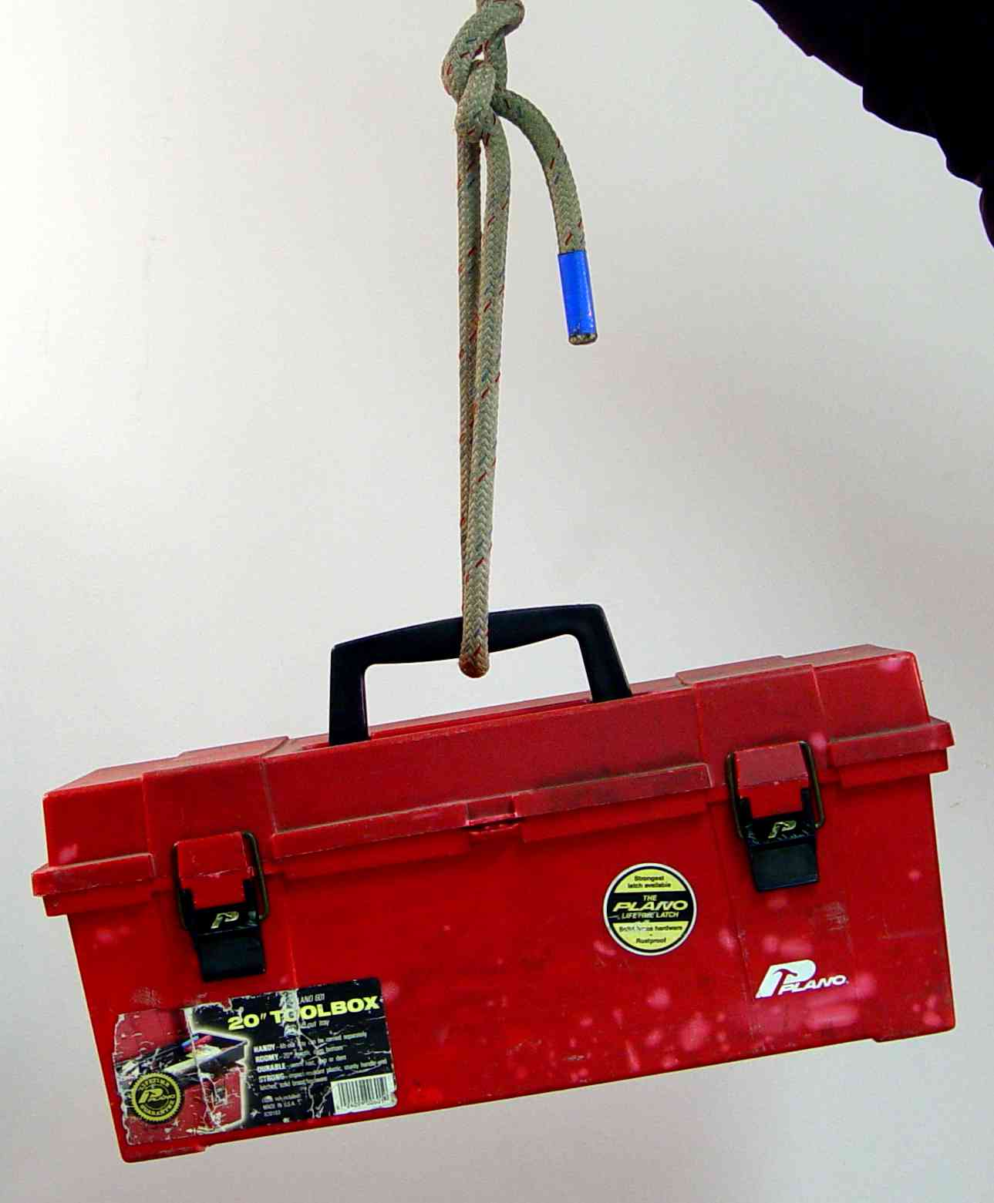 |  | 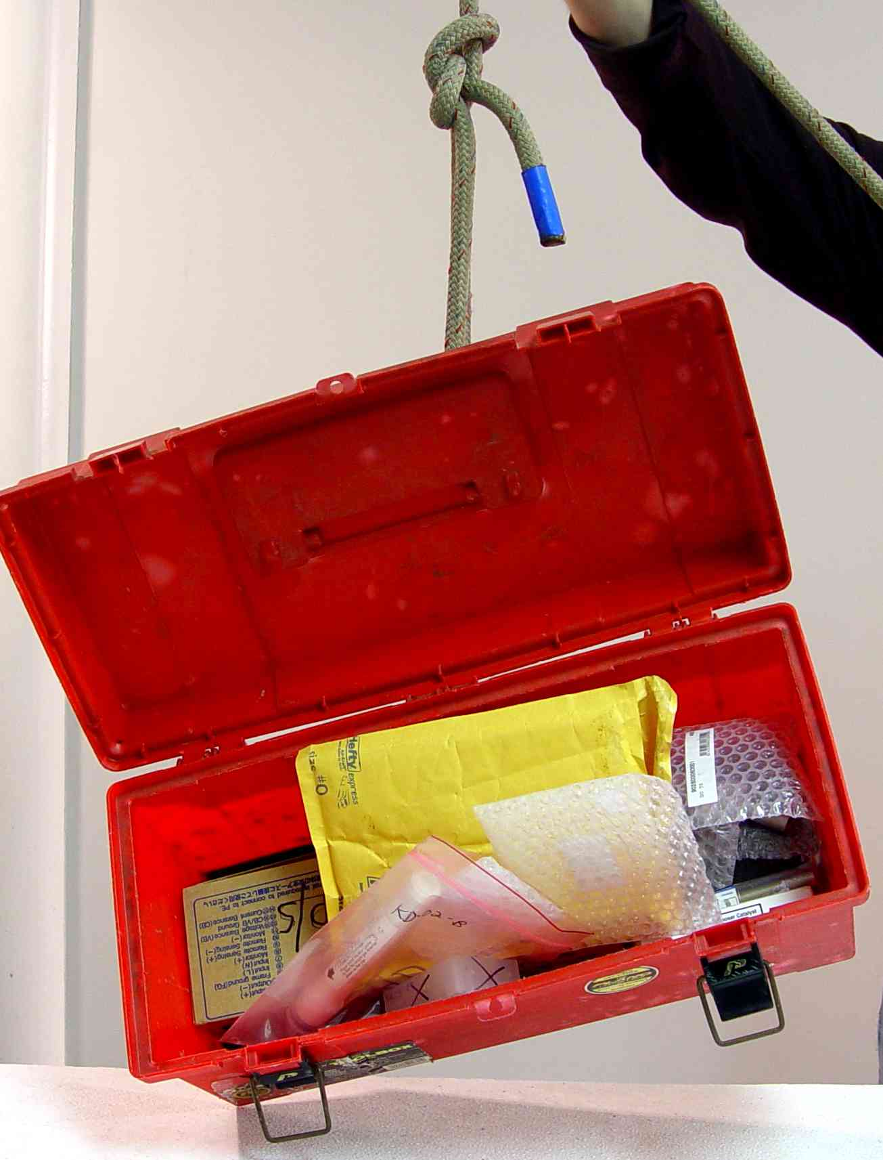

Better way…wrap the rope around both axes of the box and then through the handle.
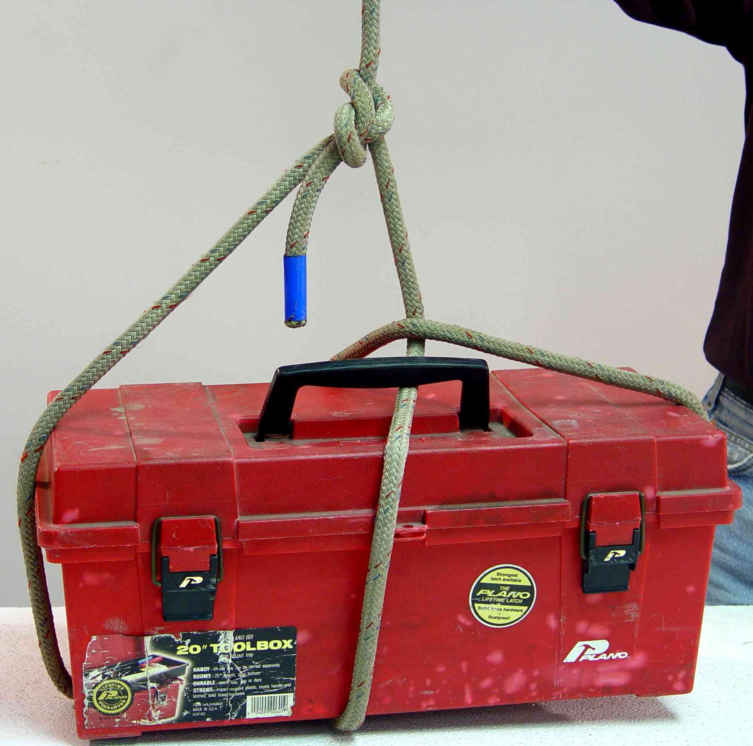

Using a Probe Knot

Step 1

Form a half-hitch at the top of the probe. Wrap the rope so that the free end crosses OVER the load-bearing strand. This is a basic principle in all hitches.
Leave about four feet of rope to finish the probe knot.

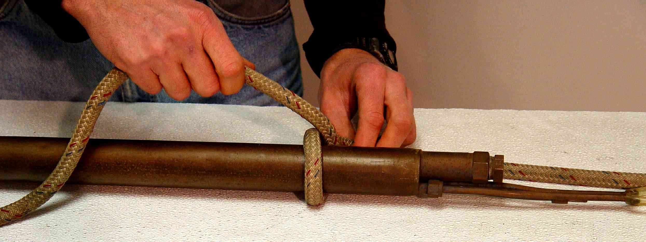
To stack pulley
(Loaded strand)
Free end of rope
(running strand)
About 4 feet of extra rope to the end

Step 2

Begin a clove hitch at the bottom of the probe by first tying another half-hitch. As before, pass the running strand over the loaded strand.

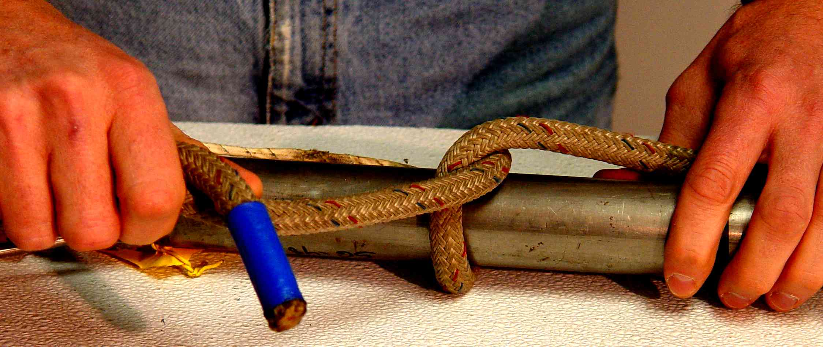
Running strand
Loaded strand (from first half-hitch at top of probe)

Step 3

Complete the clove-hitch by wrapping the rope again, in the same direction as before, and passing the free end UNDERNEATH the second wrap.

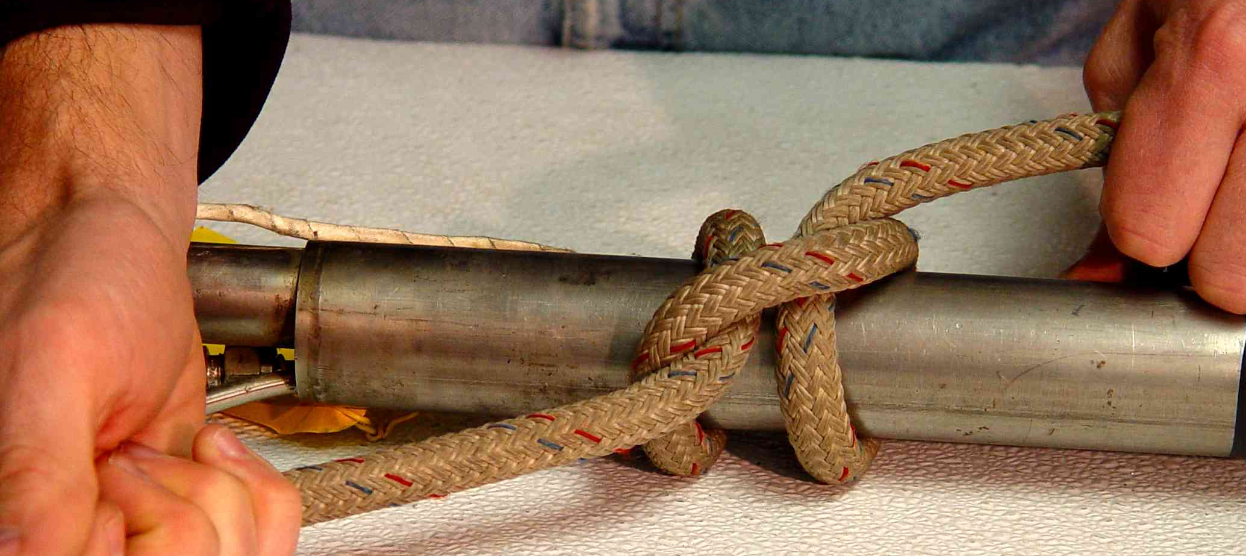
Running strand
Loaded strand

Step 4

Tighten up the clove hitch and pull the rope snug between the clove hitch at the bottom and the half-hitch at the top.

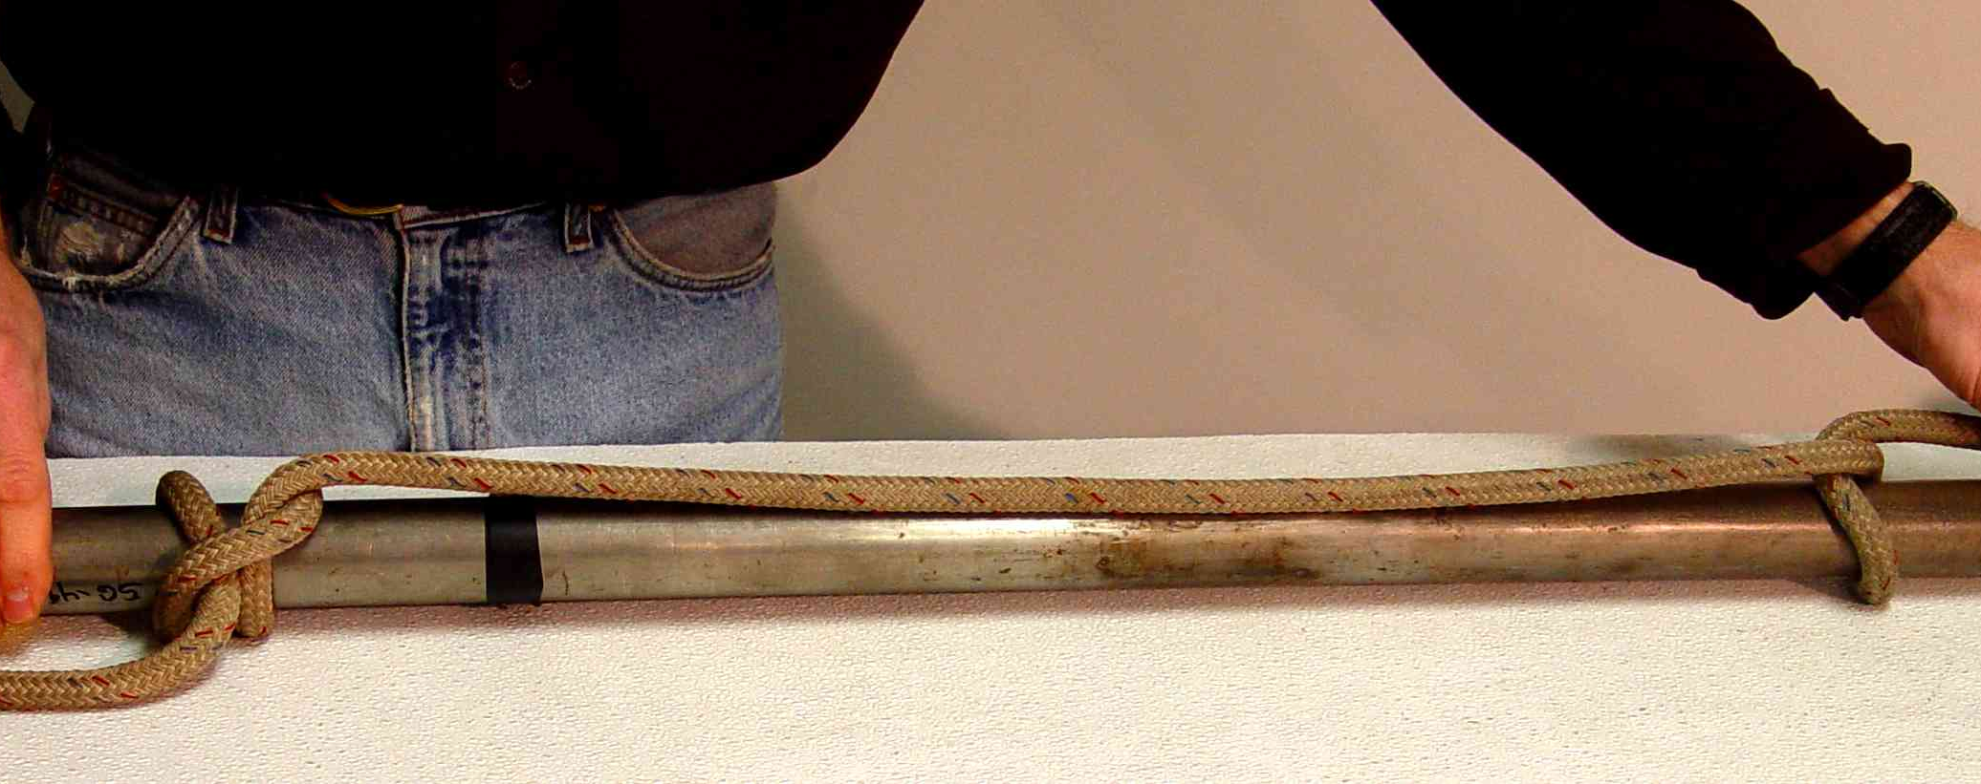
Free end
To stack
Clove Hitch
Half-hitch

Step 5

Probe is now ready to hoist.

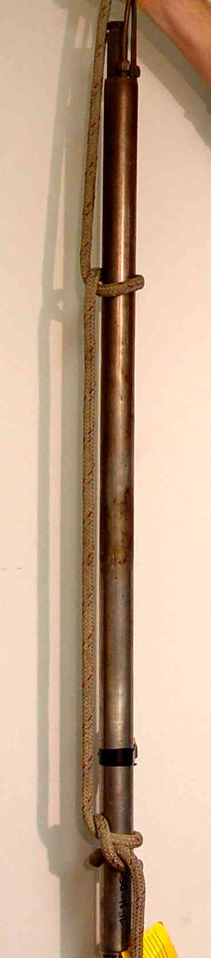
To stack
Clove Hitch
Half-hitch

Bowline used to clip hoisting carabiner.

Advantages
- Does not weaken or damage the rope as much as some other knots.
- Can be easily and quickly checked visually for correctness.
- Is easily untied even after repeated loading.

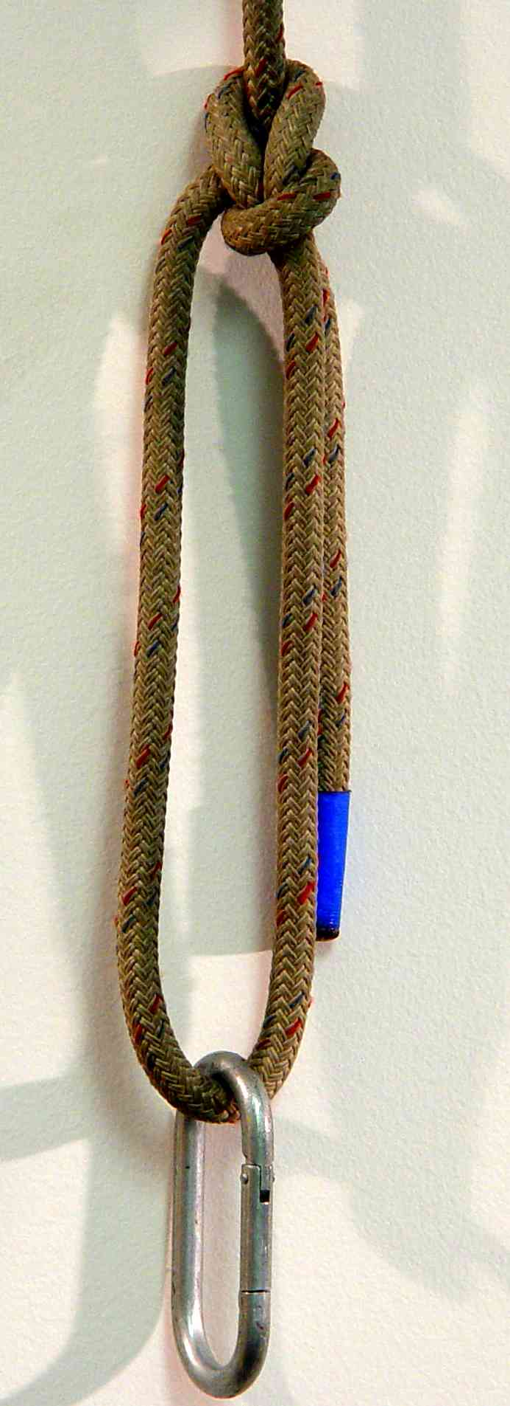
Meter Hoisting

Acceptable: Rope tied or clipped to a single handle.

This is acceptable, but suffers from the fact that there is no redundancy here. If the handle fails, then this meter is coming down, fast. Make sure that the handle is bullet-proof before relying on this technique!

Contrary to what you might think, it is not necessarily better to run the rope through two handles.

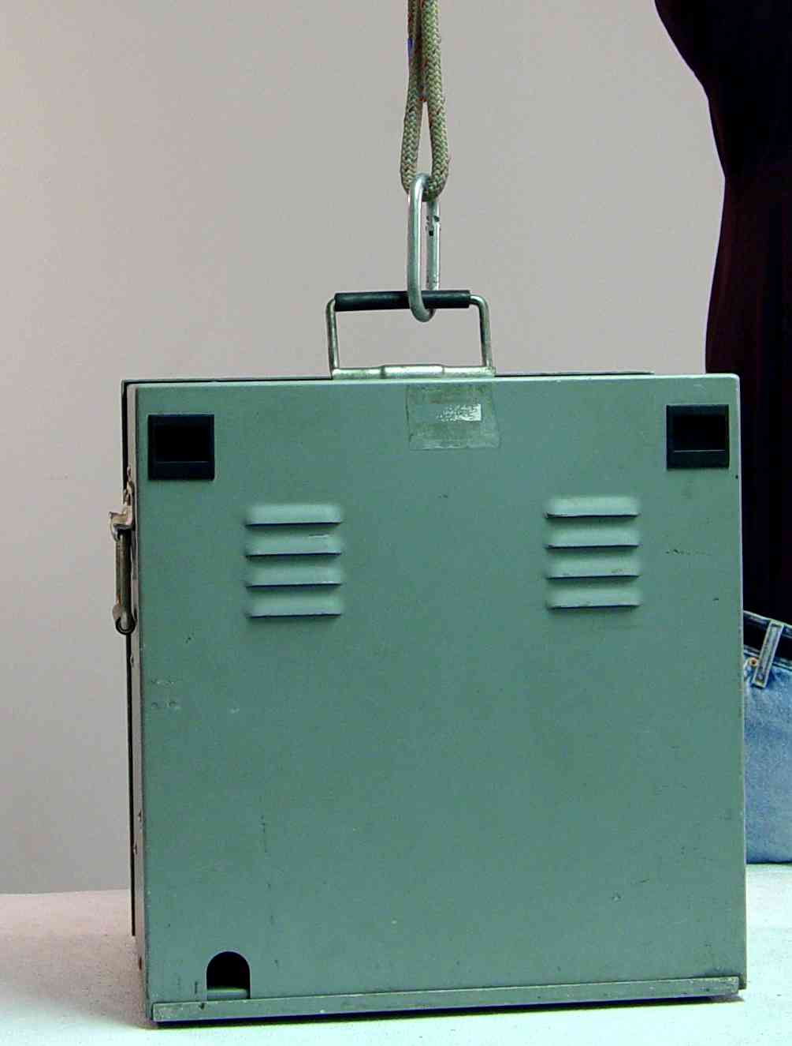

Better: Meter connected to rope using a lifting strap.

This has the advantage of distributing the force between two handles, and maintaining a redundant anchor point. Make sure that the strap is long enough to keep the inside angle below 120° (60° is optimum) to minimize the forces placed on the individual handles.

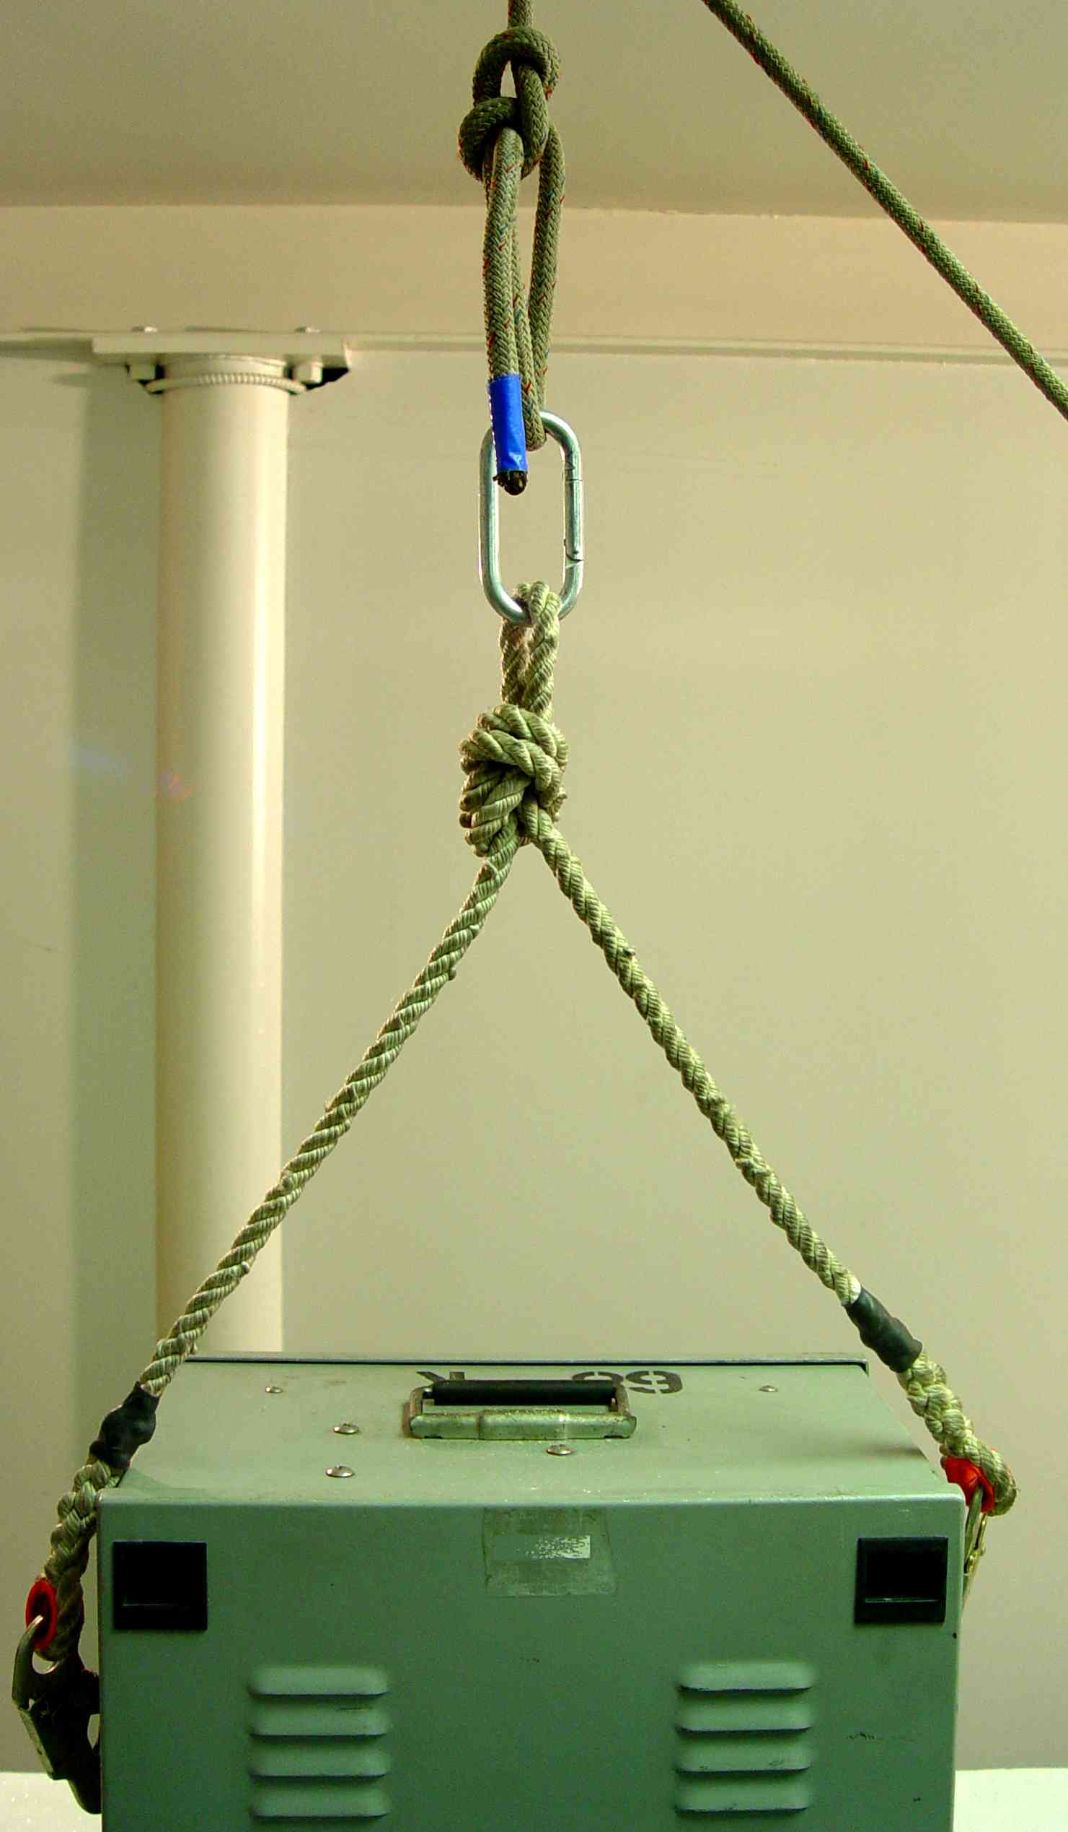
The strap should be long enough to keep this angle around 60°.
Best: Double Figure Eight (Bunny Ears)
The double figure eight, also known as the "Bunny Ears", is handy when equalizing two anchor points using one rope. Follow these steps to tie the double figure eight:
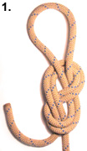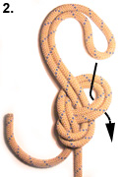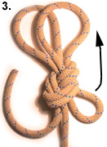
Step 1: Start with a figure eight on a bite in the end of the rope. Use a generous bite, way more than pictured, leaving a large loop of about four feet sticking out the top.
Step2: Feed this large loop back into the figure eight.
Steps 3, 4 & 5: Continue feeding the large loop through. Not too much though, so as to leave the twin "ears" behind. They each need to be roughly 18 inches or longer. Now tuck the large loop upwards, under the knot and finally over and around the twin "ears".
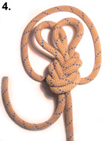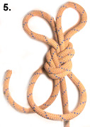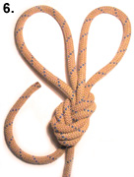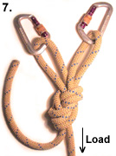
Steps 6 and 7: Pull the "ears" tight, and clip a carabiner to each.
Step 8: Clip the two loops to the two side meter handles.
The problem with a “conventional” meter hoisting technique:

One procedure often used is to run a rope through both side handles and then clip the loaded strand, as shown below. The thinking here is that two handles must be better than one. However, as shown in the lower figure, this is not the case if the angle formed between the clip and the loaded strand exceeds 120°, as is often the case in this set-up. The example shown here is about 140°, which results in a force on each handle of 1.8x the weight of the meter. In other words, you would be better off by just clipping to one handle (assuming the handle is securely attached to the meter!)

