Tip of the Week

February 14, 2005

Printing to Adobe

Have you ever found yourself crunching numbers into a workbook at 4:30 on a Friday afternoon because a client wants data emailed to him by close of business that day? A wave of panic sweeps over you at the prospect of being late for happy hour. In record time you furiously type in lab results into the method workbook and of course give a quick QA/QC of the data. Everything looks great, so you decide to print the document to Adobe PDF. You select Adobe PDF from the printer options and hit OK. Things seem to be working so smoothly, you’ll be out of here in no time – but wait. The Adobe program cut off the bottom of your parameters page. How is this possible? What do you do? Before throwing your computer against the wall (or at Eric Campbell) try this quick solution:

- Go to File/Print

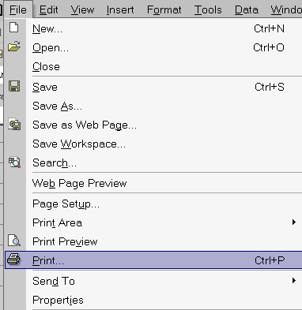

- Select Adobe PDF from the list of printer options
- Select the Properties button

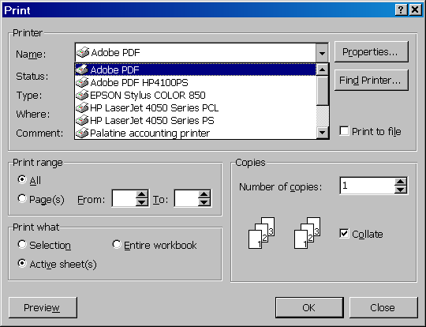

- Select the Layout tab
- Choose the Advanced button

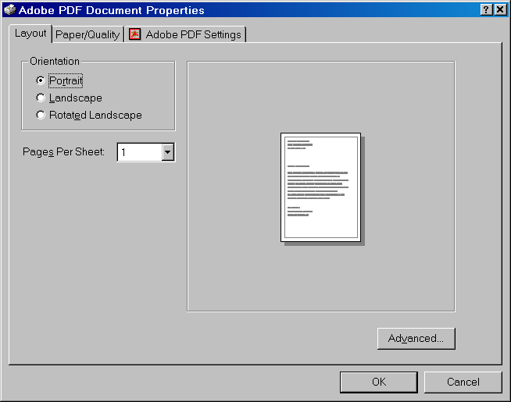

- Under Print Quality left-click once on the graphic size
- From the drop-down menu, select 300 dpi

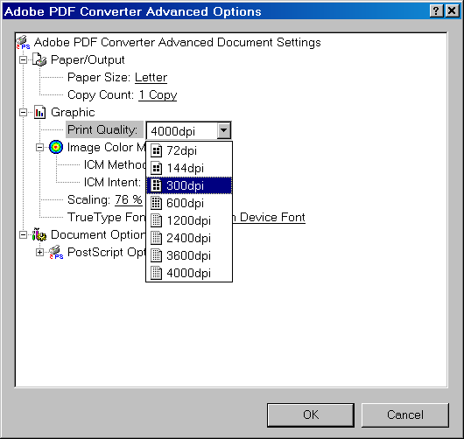

- Select OK

