Tip of the Week

November 1, 2004

Authenticating Job Logs
Job Logs are important records of what happened during a field project. We generally keep them in a bound logbook. More recently, some industrious Job Leaders have started keeping an electronic version on their laptops.

In either case, the Job Log needs to be signed and dated to authenticate that this is indeed your recording of the events. This also helps to identify the author when the log is viewed separately from the logbook.

My recommendation for authenticating hand-written logs is as follows (see examples below):

- At the top of the first page of the log, write the statement “BEGIN LOG nnnn” (where nnnn is the Job Number), your name, and date.
- At the bottom of the last page of the log, write “END LOG nnnn”, your name, signature and date.

A similar procedure should be followed for electronic logs prior to posting them to the forum.

At the beginning of the log:

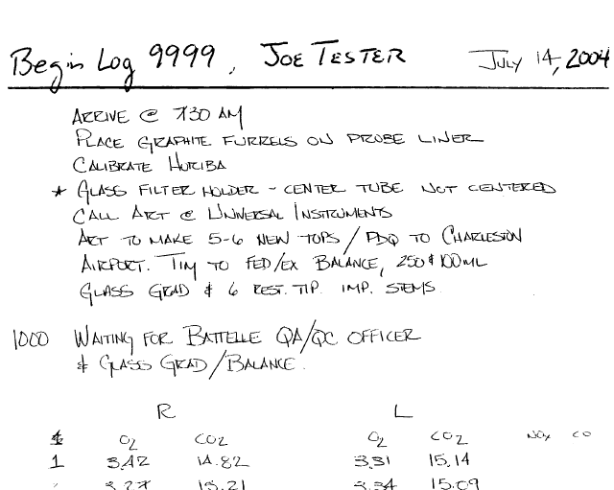
At the end of the log:

